Team 517 Operation Manual
Cameron Barnes, Cole Gutknecht, Tyler Ince-Ingram, Rafael Meza, Michael Wyrick
FAMU-FSU College of Engineering

Project Overview
1.1.1 Project Description
The objective of this project is to design a device that will be capable of transporting a 308 lb loads on the surface of the moon from the landing site to a habitation area to support NASA’s goal of lunar sustainability, development, and expansion within the Artemis Mission.
1.1.2 Key Goals
In this project the Lunar Transport team aims to produce a design or system with a working protype to demonstrate specific solutions designed to transport loads over the lunar terrain. Key characteristics of the design should include being robust and light weight. Reduction in weight translates to lower costs of delivery to the moon, therefore, with the cost of transport per mission being about $2.0 million per kilogram, the design must be cost effective. The lifecycle of the design is of particular concern, considering the harsh conditions of the moon and their degrading effects on mechanical systems. The ideal design should last up to a year with cyclical maintenance of equipment. The persistence and damaging effects of abrasive lunar dust calls for a robust design which protects mechanisms with a specific dust mitigation solution designed by the team. Considering the mass of loads needed to be carried, the team decided to design with a factor of safety of 6 which was defined by the final mechanism being able to lift 1.4 metric. All NASA and United States safety standards are met as a baseline of safety for the operating crew and the environment.
1.1.3 Assumptions
Throughout this project there will be assumptions made to focus the team’s efforts into the necessary areas for our project. It is assumed that the payload will have a maximum mass of 1.4 metric on Earth and 8.4 metric tons on the Moon. It is assumed the device or system will be built with loose tolerances. Additionally, it is assumed it shall survive the lunar night, but there is no requirement for it to transport loads during that time. It is assumed that the landing site will be close to the designated habitat area, and the device will only be required to transport loads up to 1 kilometer (km). It is assumed the device will be able to withstand temperatures ranging between 140 K (~133.1℃) and 400 K (~126.8℃). It is also assumed that the materials purchased will be budget-friendly and that would be substituted when needed in a space mission application. The habitation area is expected to be a generally flat ground area with pothole-like craters being the exception. Dust mitigation is assumed to be a necessary future work design component which is beyond the scope of our project. Automation systems will also fall into this category.
Module Description
2.1.1 Structural Frame
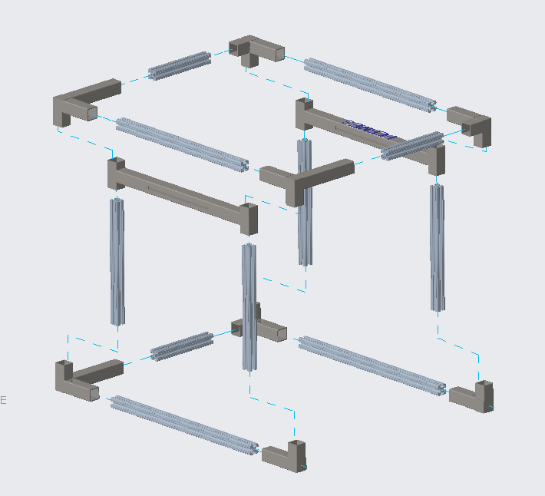
Figure 1: Frame of Structural Body
The structural frame of the body is composed of aluminum x-beams which are connected together by carbon steel as the corners of the device experience the most stress. A low carbon steel platform is included in the middle of the structure which is explained further in the section below.
2.1.2 Linearly Actuated Platform
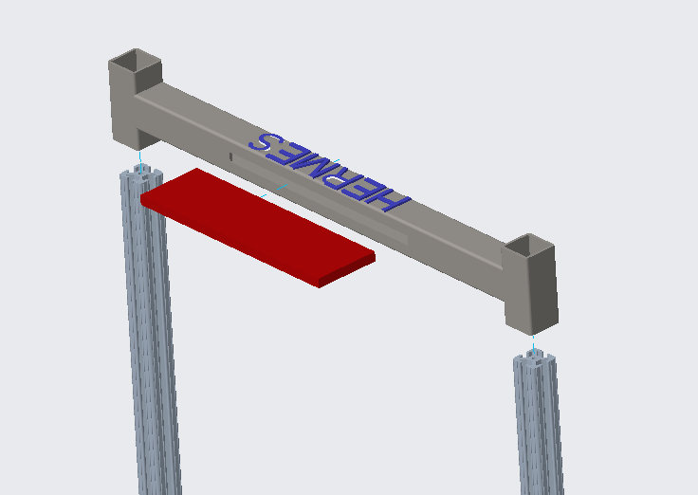
Figure 2: Actuating Platform
As seen in figure 2, the central platform on either side of the device includes two steel sleeves welded to a hollow low carbon steel beam. Additionally, a slot was cut into the platform where a steel plate was then welded to the beam. Teflon inserts were added to the inside of the steel sleeves to reduce friction while sliding.

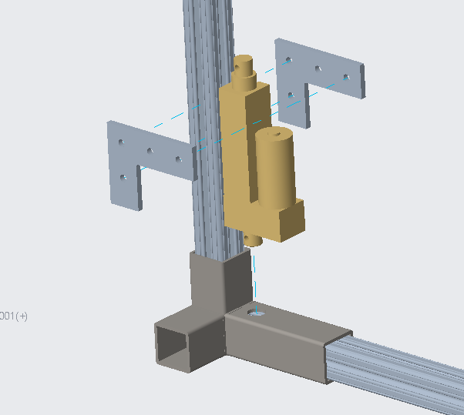
Figure 3: Linear Actuator Mount
Figure 3 shows a fork platform actuator. There are four linear actuators which all work together to lift the platform. These actuators are clamped onto the structural pillar with a pair of L shaped braces and held steady at the bottom with a single bolt running through the eye of the actuator, seen on the bottom surface.
2.1.3 Drive System
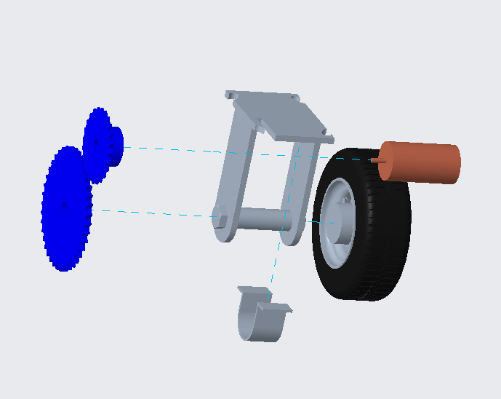
Figure 4: Drive System
The drive system connected to each four wheels is made of the following components: a single wheel mount, a brushless DC motor, a U-shaped motor attachment, and two gears.
2.1.4 Electronic Components
The following components were used to assemble the full electrical circuit of Hermes:
- 2 9V Energizer Battery
- 4 Brushless DC Motors: Spectrum Firma 2050Kv Brushless Motor
- 4 Electronic Speed Controllers:
- 4 Linear Actuators: DC House 1000N High Speed 14 mm/s Black Actuator
- 2 Motor Drivers: L298N
- 2 Lipo Batteries: Zeee 6S Lipo Battery
- 4 AA Batteries
- 1 RC Controller: FlySky
- 2 RC 6 Channel Receivers: FlySky FS-I6X
- 1 Arduino Mega
The wiring diagram displayed below demonstrates the physical electrical connections for one side of the rover. The same assembly would be duplicated on the other side. It should be noted that on one side an additional step needed to be completed in order to bind the second receiver, bought separately from the transmitter to the RC Controller.
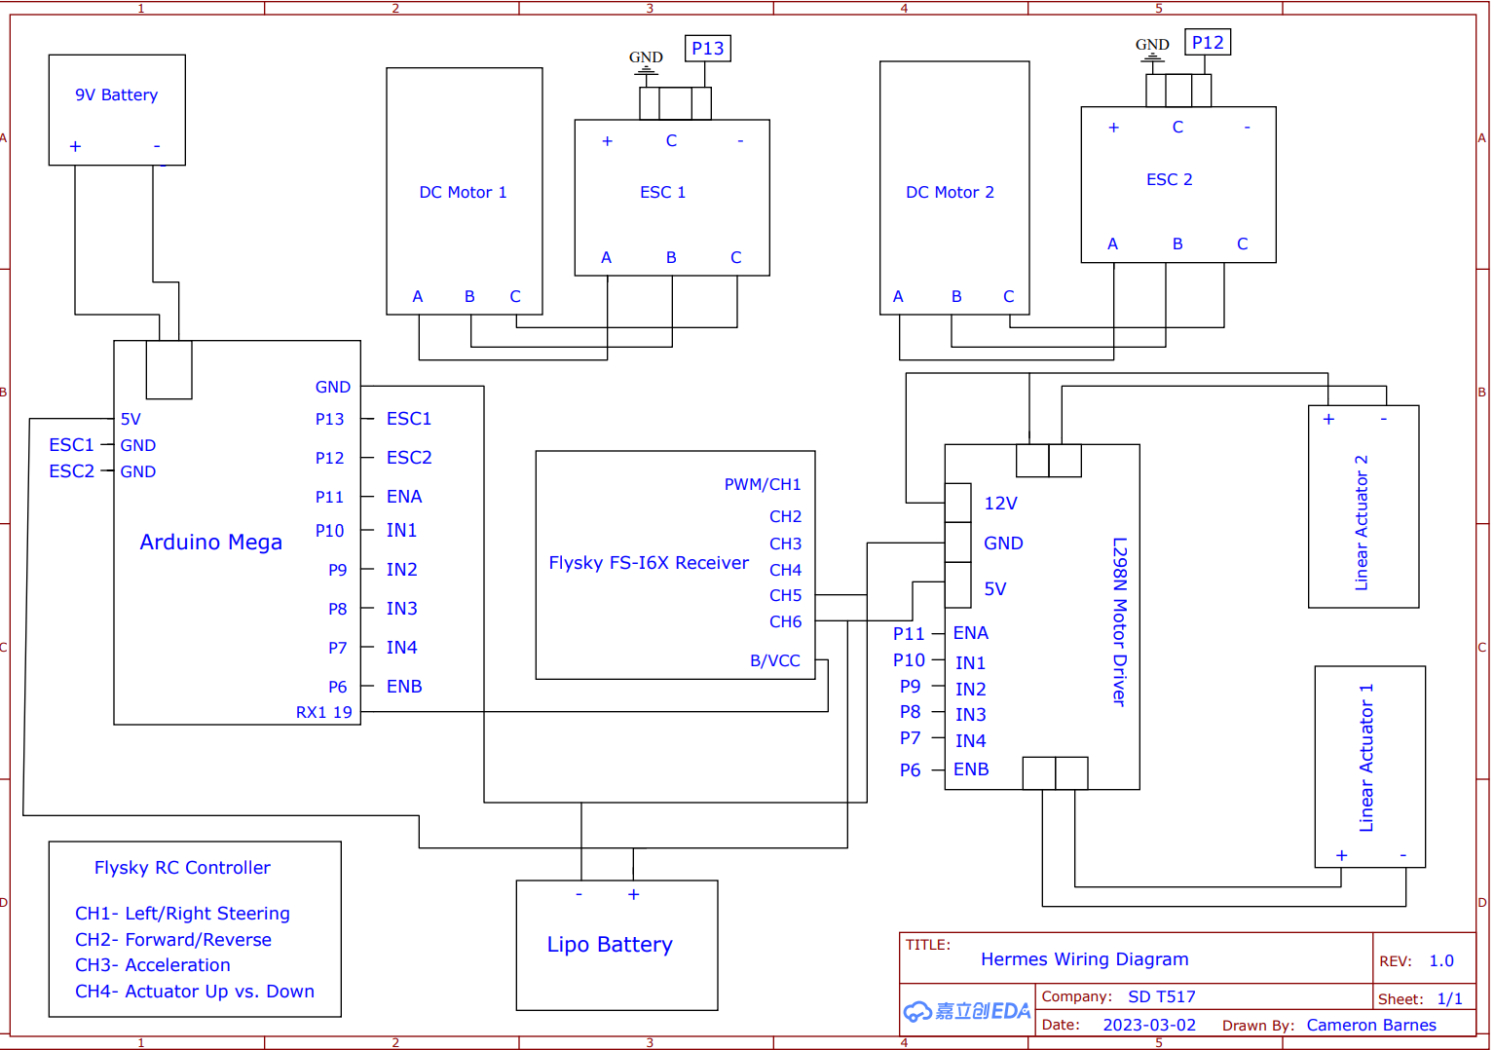
Figure 5: Wiring Diagram
The following pseudocode was developed to display the logic used in the final Arduino Code for the Hermes vehicle:
Initialize IBusBM library
Initialize CH 0-3
%Ibus library begins indexing at 0
% Ch 0: Forward and Backward
% Ch. 1: Left and Right
% Ch. 2: Acceleration
% Ch. 3: Toggle Switch for Linear Actuators
Initialize Motors A & B, Linear Actuators A & B
Begin Loop ()
If Motor A/Motor B dir = 1: Forward
If Motor A/Motor B dir = 0: Backward
Motor A/Motor B speed = Motor A/Motor B speed + Ch2 speed
Motor A = Motor A – Ch1 %Moves left vs. Right
Motor B= Motor B + Ch1 %Moves left vs. Right
Switch= 1 %linear actuators move up
Switch= 0 %Linear actuators retract down
Drive the Motors
Delay
End Loop

Integration
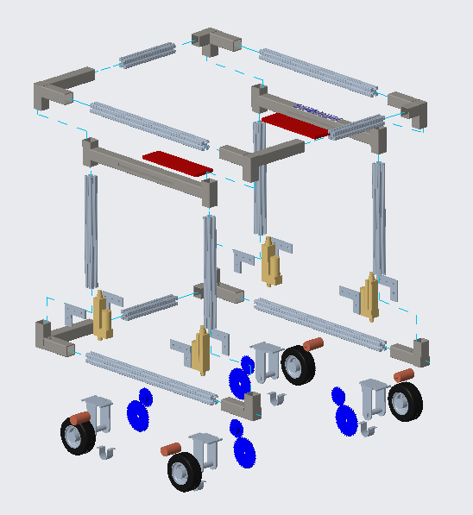
Figure 6: Exploded View of Entire Assembly

Our device has been broken down into four main building components: frame structure, mechatronics, drive terrain, and lift system. For our structure, we will be connecting eleven aluminum x-beams with corner brackets for extra support. The corner brackets will be secured to the x-beams by a bolt that will run through both the bracket and beam. Our wheel mounts will be fastened directly to the bottom four corners of the aluminum x-beams, which will hold 6 inch pneumatic wheels. There will be four linear actuators on each corner of the bottom aluminum x-beam, as well as four motors mounted above each wheel. The linear actuators and motors will both have their own housing, which will enable them to be securely fastened to the frame.
The lift system will consist of two metal bars that will run parallel to the longest side of the frame. The linear actuators will be attached to the bottom of these bars, allowing the lift system to move vertically. Steel plates will be welded to the inside of these two metal bars acting as a “forklift” mechanism.

Operation
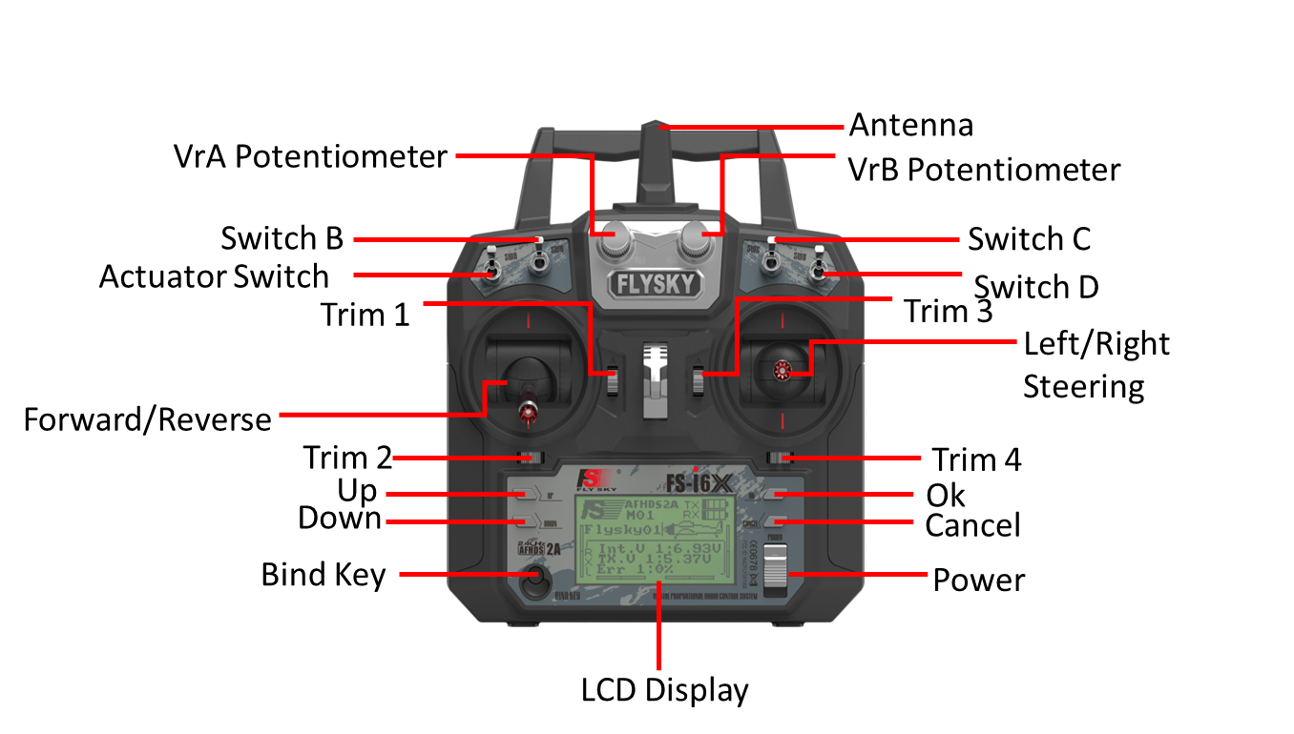
The following figure showcases the controller diagram for the Hermes Rover:
Figure 7: Hermes RC Controller Diagram (Front)
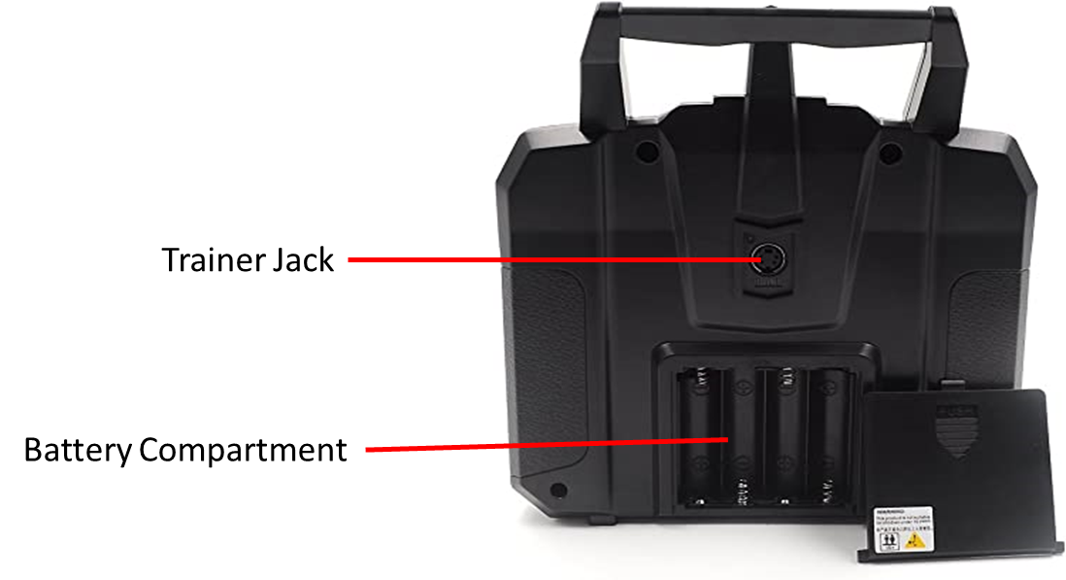
Figure 8: Hermes RC Controller Diagram (Back)
Follow the steps to install the transmitter battery:
1. Open the battery compartment.
2. Insert 4 fully-charged AA batteries into the compartment. Make sure that the batteries make good contact with the battery compartments' contacts, with the correct polarity.
3. Replace the battery compartment cover.
Once the transmitter batteries are installed, power on the controller and refer to the display to ensure the receiver is connected. Refer to Troubleshooting if any issues arise with controller setup. The RC Controller user manual can also be followed to modify the channel set up. Channel 4 must be connected to the toggle stick instead of the preset setting.
Additionally, to utilize the controller code created by the team shown in Appendix B, the user must download the “IBusBM” from the Arduino source library.
Follow the steps to install the IBusBM library:
- Open Arduino
- Open Tools à Library Manager
- Search “IBusBM”
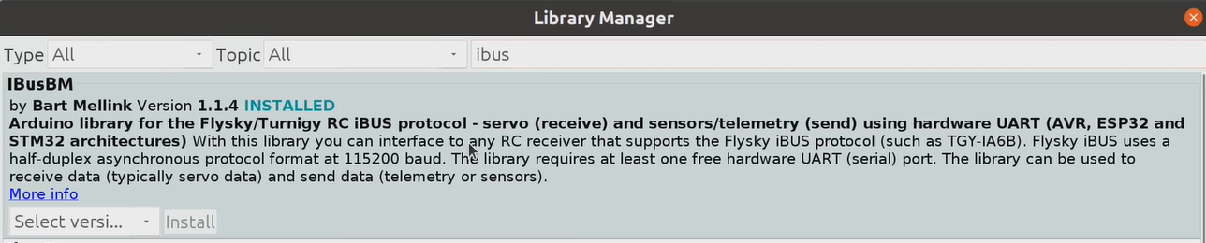
Figure 9: IBusBM Library
Once the library is correctly installed, Arduino will display the blue “installed” title next to the library. Please check that it was properly installed before continuing.
When operating Hermes, ensure that the controller diagram is followed to operate Hermes efficiently. Await a beeping noise from the motors to ensure they are ready to run, following this use the throttle to guide Hermes to the packaging container. Ensure the forks are in line with the underside of the packaging sides and the magnets click into place. Use the “Actuator Switch” to command the four linear actuators to move upwards. Following this, use the throttle to reverse directions and transport the package to a desired location. Once the location has been reached, set the “Actuator Switch” into the downwards position to begin lowering the actuated platform. Once the package rests on the ground surface, use the throttle to reverse Hermes and drive to the next chosen location.
Troubleshooting
To ensure proper connection between the transmitter and receiver ensure the two devices are within 15 feet of each other. Ideally, within close proximity at the time of connection (less than 5 feet). Connecting to an environment without obstructions between either device is the preferred situation. Check to make sure both the RC remote and the LIPO batteries are fully charged. To prevent error messages when powering up the RC transmitter, all switches need to be up, and throttle needs to be down, or a warning message will appear. The transmitter will beep when it finds the receiver. If you don’t hear this beep, then something is wrong with your connection. Retry the steps above to ensure a black slate before attempting to connect again. If issues persist, check the wiring to ensure all components are clean and properly connected to their terminals.
For the drive system, a common issue can be the meshing of the gears failing. Like a bicycle chain, the gears may encounter scenarios that push them off alignment. In this case, with the power turned off, realign the gears by manually repositioning and if needed unmounting and remounting them onto their axels. To mount the wheel gear, loosen the four bolts holding it in place and swap with new hardware if necessary. To mount the motor gear fit it tightly onto the motor axel and tighten the set screw onto the motor axel.
If at any point joints or connections produce noise that indicates a loose fit. Check comer joint bolts making sure all are tightened down and in the right place. Check the wheel mounts to make sure everything is in place. Check the motor mounts and the actuator casing to make sure they are in-line with the platform and wheel gears respectively. If the noise originates from the gears, ensure a tight tolerance between both parts and lubricate if necessary.
Appendix A – CAD Drawings
The CAD drawings of the parts in the assembly is included as a pdf attachment.

